Designs and Principles

1.singletonPattern

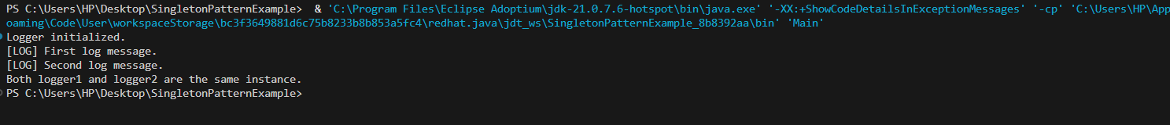

2.Factory Method Pattern

